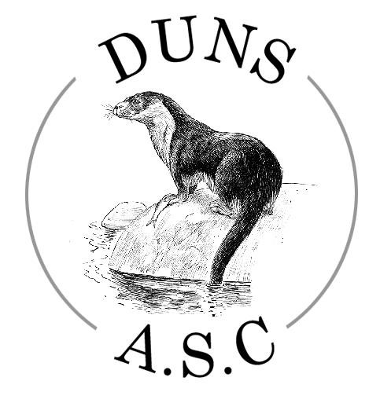

Duns Amateur
Swimming Club

Invite you to

The Duns 500 Swim Meet

Saturday 23rd May 2026

At Duns Swimming Pool Duns TD11 3QQ

License:
L3/ED/037/MAY26

The DUNS 500

You are cordially invited to send a team of young swimmers to the Duns 500 Swim Meet to be held at Duns Swimming Pool on Saturday 23rd May 2026.

Due to limited space we will only allow a maximum of two coaches/helpers per club on poolside. There will be an indoor screen showing a livestream of the events to which parents are welcome attend.

EVENTS: 100m all strokes, 50m butterfly (11 and under), 100m IM
See attached order of events.

AGE GROUPS: 9-11 years, 12 & 13 years, 14 & over.
Age on the day of the meet.
Events will be swum with age groups combined and seeded on entry times.
Results will be reported by age group.
All events are heat declared winners.
NO SWIMMERS PERMITTED TO SWIM UNDER THE AGE OF 9

AWARDS: Medals to be awarded to 1st, 2nd, 3rd placed in each age group for each event for males and open, and females.

SESSIONS: Doors open at 9am.
There will be 2 sessions as follows:
Morning: 9.25am warm up 10:00am Start
Afternoon: 1:00pm warm up 1:35pm Start

Warm up and session times may vary from those listed once the draft programme has been prepared.

ENTRY FEES: £5.00 per individual 50m event . £5.50 per individual 100m event

Payment by BACS. Please find details on the enclosed Summary Sheet.

ENTRIES: All entries to be made on Hy-Tek entry file.
To request a file please email dunsasc2022@gmail.com
Please send your entry file and a completed summary sheet to:
Dunsasc2022@gmail.com

ENTRIES SECRETARY: Morag Stephens

Prenderguest Farmhouse Eyemouth TD14 5RW

Closing date for entries is midday on Wednesday 22nd April 2026

NO LATE ENTRIES WILL BE ACCEPTED

WITHDRAWALS: | A draft programme will be issued prior to the event. Please email withdrawals prior to the meet to dunsasc2022@gmail.com or on poolside by 9.30am on day of meet. No refunds will be given once the draft has been issued.
OFFICIALS: | We ask that clubs entering please indicate officials willing to officiate at this event. We ask that officials bring a refillable water bottle.
GENERAL | The meet shall be held under S.A.S.A. rules.
INFORMATION | All entrants must have paid their membership fee to SASA or equivalent body.
ADDITIONAL | Please remove outdoor footwear before entering the changing area.
INFORMATION | No outdoor shoes on poolside.
 | Small bags only on poolside.
 | No food to be taken on poolside.
TRANSGENDER & | As of 1 January 2024, the Scottish Swimming Transgender & Non-Binary
NON-BINARY: | Competition Policy was implemented nationally across all aquatics sports. The policy and FAQs can be found here. Any policy related matters that arise during the event should be reported to and will be recorded by the Meet Convenor/Lead Referee and these matters will be communicated to and managed post event by the relevant Scottish Swimming Staff. At no point will members be challenged on the day of a competition with any matters being resolved post event. As a result of this policy being implemented, any competitor intending to compete within the Female category at this event will be required to provide confirmation that their birth sex is female when signing up to the meet conditions through entry. By entering the Female category, athletes are therefore confirming their birth sex is female and are eligible to compete in the Female category.

PHOTOGRAPHY STATEMENT

DUNS 500
By attending the event either as a participant, volunteer, team staff or spectator, you accept that any photographs / videos taken will not be used for illicit purposes or that pictures / films produced will not be altered in any way or uploaded onto the web without the consent in writing of the person(s) photographed / filmed. The use of mobile phones or other electronic devices capable of photography are not permitted to be used at any time in the changing village, toilets or shower areas.
Spectators who wish to take images are requested to focus on their own family member as much as reasonably possible and to avoid including other participants in images, particularly if those images are being shared with family and friends or through social media platforms.
The use of professional camera equipment and flash photography is prohibited at the Event. Only accredited media can use this type of equipment. Media wishing to gain accreditation must put the request in writing to the event organiser prior to the start of the competition.

The DUNS 500

Order of Events

Event No | Male & open/ Female | Age Group | Event
101 | M&O | 9 & over | 100m Backstroke
102 | F | 9 & over | 100m Backstroke
103 | M&O | 9 & over | 100m Breaststroke
104 | F | 9 & over | 100m Breaststroke
105 | M&O | 9 & over | 100m IM
201 | F | 9 & over | 100m IM
202 | M&O | 9 - 11 | 50m Butterfly
203 | M&O | 11 & over | 100m Butterfly
204 | F | 9 - 11 | 50m Butterfly
205 | F | 11 & over | 100m Butterfly
206 | M&O | 9 & over | 100m Freestyle
207 | F | 9 & over | 100m Freestyle

The DUNS 500

This form must be completed electronically and returned with BACS payment.

Club Name:

Club Contact’s Name:

Position in Club:

Email:

Total Male & open 50m Entries = _____ (No.) @ £5.00 = £_____________

Total Male & open 100m Entries = _____ (no.) @ £5.50 = £ _____________

Total Female 50m Entries = ______ (No.) @ £5.00 = £ _____________

Total Female 100m entries = ________ (No.) @ £5.50 = £ _____________
Total £ _____________

BACS Payment reference DUNS5 followed by Club Code e.g .DUNS5EDSX Bank Account Details:
Sort Code: 80-13-51
Account No: 00133501
Account name: Duns Amateur Swimming Club

Form to be returned to:

Dunsasc2022@gmail.com

Morag Stephens Prenderguest Farmhouse Eyemouth TD14 5RW

Names of officials and their qualifications:
.
___________________________________
___________________________________
___________________________________
____________________________________

